Project Brief

Create website for Brooklyn Outdoor Film Festval
November 28, 2017

Author: Daniel Kukula

Summary
Create advertisement website for Brooklyn Outdoor Film Festival. Festival is having place at Brooklyn Bridge Park from 5th to 8th August. The website should show that films can appeal to audiences of all ages.

Stakeholders
Daniel Kukula: Developer – responsible for creating frontend and backend of the website, Daniel is experienced in creating this type of projects.

Goals
- Create a website for the festival and get it online.
  - Information about the festival.
  - Films showing.
  - News or announcements about the festival.
  - Use professional web address relevant to the festival.
- Set up online accounts for communication online and add to the website.
  - Twitter, Facebook and Instagram links in navigation bar and footer.
  - Links to the city of Brooklyn’s news website, and the Brooklyn Bridge Park’s website.
- Allow registering through the website.
  - Shows are free but the capacity for each show is 5,000 people.
  - Save registered users to a mongoDB database.
  - Allow for preregistration – remainder email send when registration avaliable.
- Get 5 000 people for every movie.
  - Allow to register for a couple of movies in a row.
- Save users to the database.
  - Allow sending announcements to registered users.
  - Allow sending tickets.

Timeline
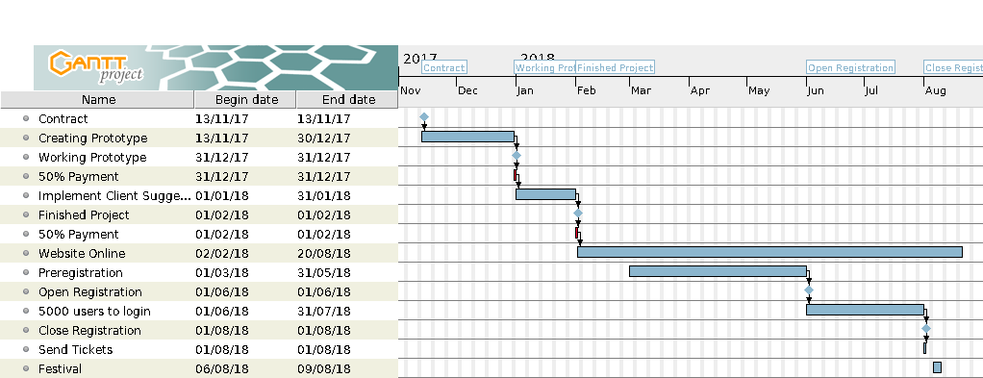

Budget
3,500$ for getting the page up and running
Hosting | 120 $
Domain | 30$
Stock Photos + website theme | 350$
Developer | 3000$

Technical Specification
The main technical choices I made when creating the website:
I have choosen to make the website as a 1 page webpage because thats the latest trend in user interface design. All the major companies like facebook or google use this kind of interface on their webpages.
The website was created using latest Bootstrap 4 CSS library which focuses on usability, user experience and helps to make the site interactive.
To enhance the default bootstrap look I used some custom tricks:
- On the website, I used a dark theme with white text which should refer to a dark cinema and closing credits in movies.
- I added some orange accents which make a nice contrast with the dark theme.
- Additionally, the program section is made using complementary colours to orange which again makes a good impression and doesn’t overhaul us with orange colour on the page.
- To break out of boundaries I used diagonal borders between sections. I used SVG images, these look good no matter the screen size or resolution. The diagonal lines all point in the same direction giving an even flow to the content.
Starting from the top of the page we got a navbar fixed to the top, which is always visible. This allows users access to the most important parts of the website no matter where they currently are on the page. On the navbar I exposed our sponsor's links as per request.
Next is a bootstrap carousel with links to Register section, Brooklyn Bridge Park, Festival’s social media and News Website. I used high-quality stock photos made by professional photographers to enhance the look. I also avoided dark overlays on top of the images and used only a slight shadow to make the text better readable on top of light parts on the images.
Carousel text scales up on larger devices and some parts are hidden on smaller screens to keep the site simple without information overload.
Next is the News part – this is made using bootstrap accordion which collapses article bodies showing only the most recent, older ones show up after clicking on the title. It can be easily extended with new announcements. I used accordions to keep the site minimalistic.
Movies section uses bootstrap nav-pills to switch between different movie genres. This allows for easier access to interesting sections. Movies information are made using bootstrap cards. This provides a clean look and easily scales on smaller screens. Depending on the screen size the sections are shown as 4x1 2x2 or 1x4 grid
Next section is the festival program made using list group – with custom coloured heading and exact screening time shown in a bootstrap pill. Movie titles are different length and the oval pill shape helps to hide that the lists are not symmetric. This section is almost always shown as 1 row of 4 lists only on small screens it’s vertical.
Last part is book tickets section: on top, there is a countdown clock showing when the registration ends – it's made using card deck with 4 cards. This is a call to action section that shows that the registration closes soon and pushes the user to register on the website. The countdown is made using javascript.
The second part of this section is the Register formular which is made as a form with two columns. This also scales nicely to one column on phone screen.
On the bottom of the formular, there's a choose movie drop-down menu which changes depending on the day that we have chosen to register for using radio buttons. This is made using javascript. On the bottom, I made a footer with the most important links and a copyright notice. The footer uses bootstrap grid. As a domain name I suggest to use: brooklyn-outdoor-film-festival.org.

